How accurate is your GPS?
GPS satellites broadcast their signals in space with a certain accuracy, but what you receive depends on additional factors, including satellite geometry, signal blockage, atmospheric conditions, and device design features/quality.
For example, GPS-enabled smartphones are typically accurate to within a 4.9 m (16 ft.) radius under open sky (VIEW SOURCE AT ION.ORG). However, their accuracy worsens near buildings, bridges, and trees.
High-end users boost GPS accuracy with dual-frequency receivers and/or augmentation systems. These can enable real-time positioning within a few centimeters, and long-term measurements at the millimeter level.

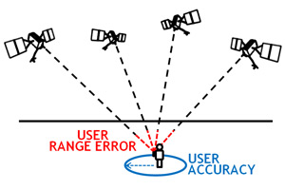

Why does my GPS sometimes show a different location than to where I am?
Many things can degrade GPS positioning accuracy. Common causes include:
- Satellite signal blockage due to buildings, bridges, trees, etc.
- Indoor or underground use
- Signals reflected off buildings or walls ("multipath")

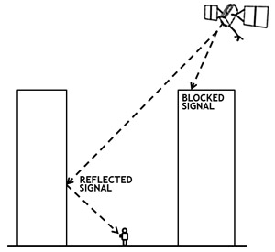

High accuracy
When you select the High accuracy location service mode, you are allowing multiple networks to pinpoint your precise location (hence the name High accuracy). It calls upon every service available: GPS, Wi-Fi, Bluetooth, and/or cellular networks in whatever combination available, and uses Google's location services to provide the most accurate location.

